NUCL 402 HMWK 3

1. Research Power Reactor Reactivity
   1. Power Increase
 $$P_{1}=\frac{β\left(1-ρ\right)}{β-ρ}*P_{0}$$

 $$\frac{P_{1}}{P_{0}}\left(β-ρ\right)=β-βρ$$

 $$\frac{P_{1}}{P_{0}}β-\frac{P_{1}}{P_{0}}ρ=β-βρ$$

$$\frac{P_{1}}{P_{0}}β-β=\frac{P_{1}}{P_{0}}ρ-βρ$$

$$ρ=\frac{\frac{P_{1}}{P_{0}}β-β}{\frac{P_{1}}{P_{0}}-β}=\frac{\frac{3 MW}{1 MW}0.0065-0.0065}{\frac{3 MW}{1 MW}-0.0065}=0.00434 \$=434 pcm$$

2. Scram
$$ρ=\frac{\frac{P_{1}}{P_{0}}β-β}{\frac{P_{1}}{P_{0}}-β}=\frac{\frac{1 MW}{3 MW}0.0065-0.0065}{\frac{1 MW}{3 MW}-0.0065}=-0.01326 \$=-1326 pcm$$

2. PWR Rod Worth
$$ρ_{w}=\frac{f_{R}}{1-f_{R}}$$

$$\frac{1}{f_{R}}=\frac{\left(z^{2}-y^{2}\right)d}{2a}+E\left(y,z\right)$$

$$E\left(y,z\right)=\frac{z^{2}-y^{2}}{2y}\left[\frac{I_{0}\left(y\right)K_{1}\left(z\right)-K_{0}\left(y\right)I_{1}\left(z\right)}{I_{1}\left(z\right)K_{1}\left(y\right)-K_{1}\left(z\right)I_{1}\left(y\right)}\right]$$

$$R=175 cm$$

$$a=0.6 cm$$

$$N=22$$

$$L_{T}=1.4 cm$$

$$D=0.25 cm$$

$$Σ_{t}=2.5 cm^{-1}$$

$$d=\frac{2.131D\left(aΣ_{t}+.9354\right)}{aΣ_{t}+.5098}=0.6456$$

$$R_{c}=\sqrt{\frac{R^{2}}{N}}=\sqrt{\frac{{\left(175 cm\right)}^{2}}{22}}=37.31 cm$$

$$y=\frac{a}{L_{T}}=\frac{0.6 cm}{1.4 cm}=0.429, z=\frac{R_{c}}{L_{T}}=\frac{37.31 cm}{1.4 cm}=26.65$$

$$E\left(y,z\right)=\frac{{26.65}^{2}-{0.429}^{2}}{2*0.429}\left[\frac{I_{0}\left(0.429\right)K_{1}\left(26.65\right)-K_{0}\left(0.429\right)I_{1}\left(26.65\right)}{I_{1}\left(0.429\right)K_{1}\left(26.65\right)-K_{1}\left(26.65\right)I_{1}\left(0.429\right)}\right]=-434.9288$$

$$\frac{1}{f_{R}}=\frac{\left({26.65}^{2}-{0.429}^{2}\right)d}{20.6 cm}-434.9288$$

$$ρ_{w}=\frac{f_{R}}{1-f_{R}}=-0.0185$$

$$ρ_{total}=ρ_{w}*N_{clusters}=\left(-0.0185*58\right)=-1.0752=107.52\%$$

3. Cruciform Rod Worth Spacing
$$ρ_{w}=\frac{f_{R}}{1-f_{R}}$$

$$f_{R}=\frac{ρ_{w}}{1+ρ_{w}}$$

$$ρ_{w}=-1.0752, L_{T}=1.3 cm, Σ_{a}=0.21 cm^{-1}, l=6.5 cm, a=0.2 cm$$

$$d=\frac{2.131D\left(aΣ_{a}+.9354\right)}{aΣ_{a}+.5098}=0.9437$$

$$f_{R}=\frac{4\left(l-a\right)L_{T}}{{\left(m-2a\right)}^{2}}\frac{1}{\frac{d}{L_{T}}+\coth\left(\frac{m-2a}{2L_{T}}\right)}=\frac{ρ_{w}}{1+ρ_{w}}$$

$$m=37.57 cm$$

4. Reactor Reactivity Change with Temperature

$$α_{T}=\frac{1}{k^{2}}\frac{dk}{dT}≈\frac{1}{k}\frac{dk}{dT}→k=c_{1}e^{αT}=e^{αT}$$

$$ρ=\frac{\left(1-\left(\frac{1}{k}\right)\right)}{β_{U235}}$$

$$\%=100*ρ$$

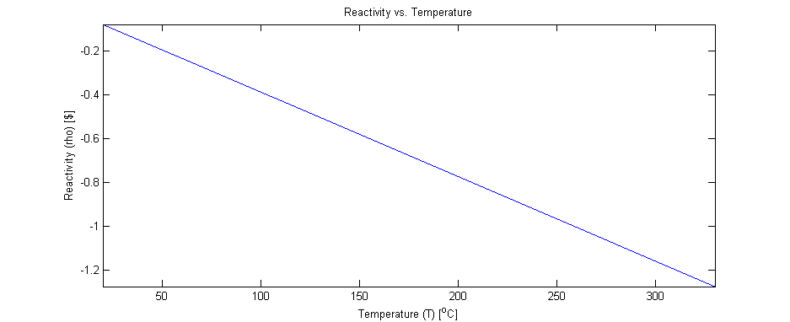

Figure 1 Reactivity vs Temperature (U235)

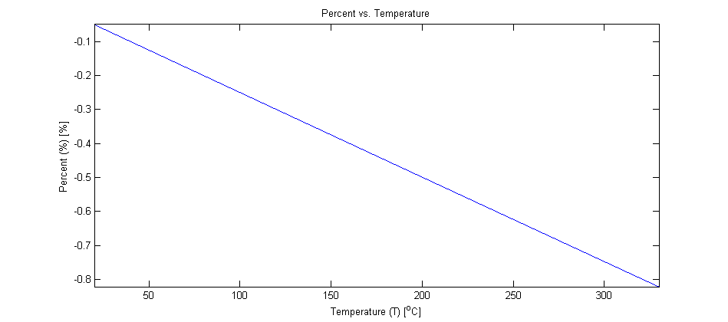

Figure 2 Precent Vs Temperature (U235)